|  |  |
| --- | --- |
| **Name:** | Bodhisatya Ghosh |
| **Class:** | CSE DS |
| **Batch:** | B |
| **UID:** | 2021700026 |
| **Experiment:** | 7 |

**Aim**: Assume that a system has a 32-bit virtual address with a 4-KB page size. Write a C program that is passed a virtual address (in decimal) on the command line and have it output the page number and offset for the given address.  
  
**Code:**

#include <stdio.h>

#include <stdlib.h>

void main()

{

    unsigned int size = 4096;

    unsigned int n;

    printf("Enter page to check: ");

    scanf("%u",&n);

    unsigned int page=n/4096;

    unsigned int offset=n%4096;

    printf("The address %u is contained in:\n",n);

    printf("Page number: %u\n",page);

    printf("The offset is: %u\n",offset);

}

**Output:**

**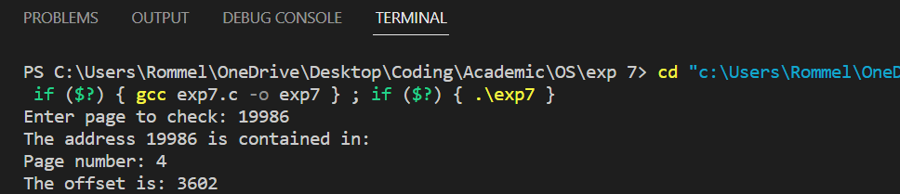  
  
Conclusion:** In this experiment we have learnt how to find out the page number and offset for a particular given virtual address.